Task 1
Age at Diagnosis vs Cancer Stage
- Question: How does the age at diagnosis vary across different cancer stages (Stage I–IV)?
- Compare mean/median age for each cancer stage and visualize using a boxplot or violin plot.

Output

- Terminal

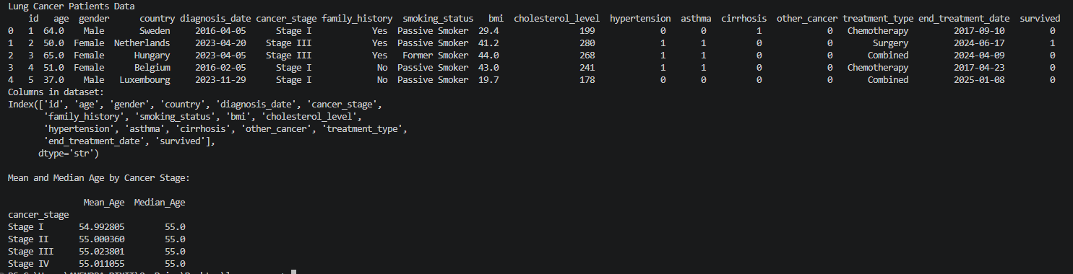

- Box Plot
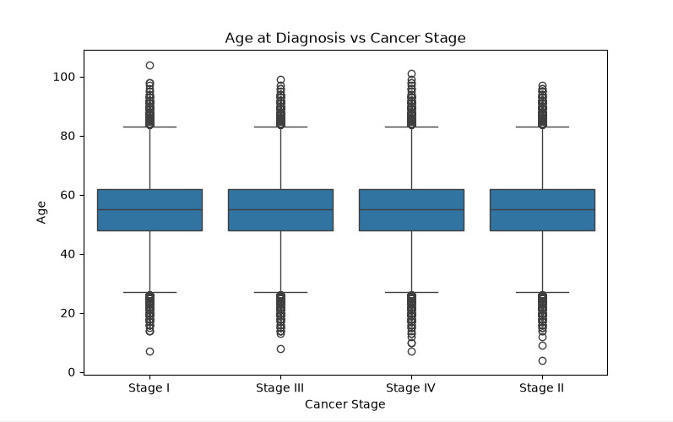
- Violin Plot
